Name : Nazeer Ahmed

CMS-ID : 023-18-0062

SECTION: CS-III(A)

SOLUTION AND CODE

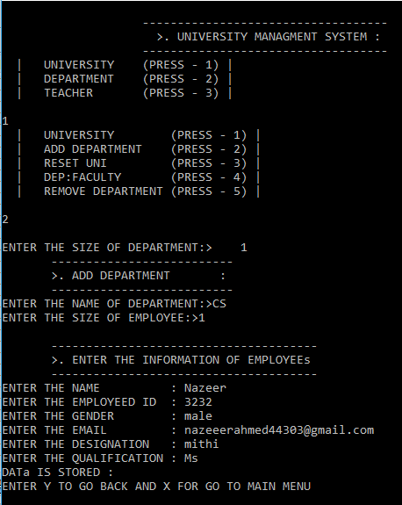

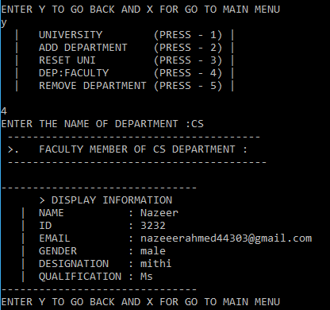

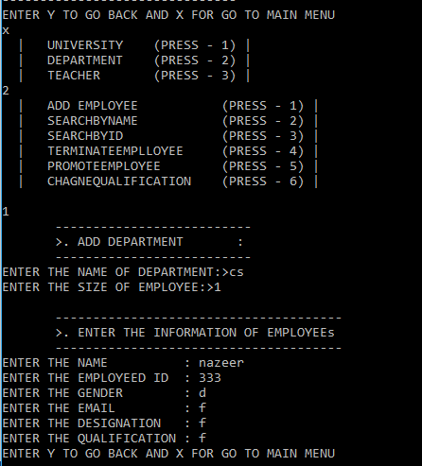

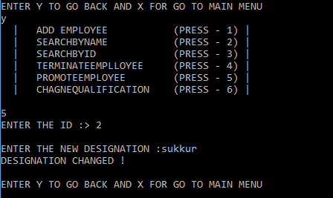

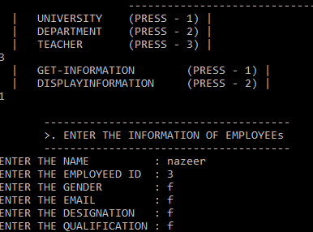

///////////////////////////////////////////////////////////////////////////////////////////////////////

#include<iostream>

#include<conio.h>

#include<iomanip>

#include<string>

using namespace std;

class Teacher

{

string Name, email, qualification,gender,designation;

int emplyeedID;

public:

////////////////////////////////////////////////////////////////////

void getTeacherInput()

{

cout<<endl;

cout<<setw(20)<<" --------------------------------------"<<endl;

cout<<setw(20)<<" >. ENTER THE INFORMATION OF EMPLOYEEs "<<endl;

cout<<setw(20)<<" --------------------------------------"<<endl;

cout<<"ENTER THE NAME : ";

cin>>Name;

cout<<"ENTER THE EMPLOYEED ID : ";

cin>>emplyeedID;

cout<<"ENTER THE GENDER : ";

cin>>gender;

cout<<"ENTER THE EMAIL : ";

cin>>email;

cout<<"ENTER THE DESIGNATION : ";

cin>>designation;

cout<<"ENTER THE QUALIFICATION : ";

cin>>qualification;

}

////////////////////////////////////////////////////////////////////

////////////////////////////////////////////////////////////////////

void dispayInfo()

{

cout<<endl;

cout<<"-------------------------------"<<endl;

cout<<" > DISPLAY INFORMATION"<<endl;

cout<<" | NAME : "<<Name<<endl;

cout<<" | ID : "<<emplyeedID<<endl;

cout<<" | EMAIL : "<<email<<endl;

cout<<" | GENDER : "<<gender<<endl;

cout<<" | DESIGNATION : "<<designation<<endl;

cout<<" | QUALIFICATION : "<<qualification<<endl;

cout<<"-------------------------------"<<endl;

}

////////////////////////////////////////////////////////////////////

////////////////////////////////////////////////////////////////////

int compareByName(string compName)

{

cout<<endl;

if(compName==Name)

return true;

}

////////////////////////////////////////////////////////////////////

////////////////////////////////////////////////////////////////////

int compareByID(int id1)

{

if(emplyeedID==id1)

return true;

// {

// cout<<endl;

// cout<<"ID IS MATCHING "<<endl;

// }

// else

// {

// cout<<"NOt matching:"<<endl;

/// }

}

////////////////////////////////////////////////////////////////////

////////////////////////////////////////////////////////////////////

void ChangeDesignation()

{

string changeDesignation;

cout<<endl;

cout<<"ENTER THE NEW DESIGNATION :";

cin>>changeDesignation;

designation=changeDesignation;

cout<<"DESIGNATION CHANGED ! "<<endl;

}

////////////////////////////////////////////////////////////////////

////////////////////////////////////////////////////////////////////

void ChangeQualification()

{

string changeQualification;

cout<<endl;

cout<<"ENTER THE NEW QUALIFICATION :";

cin>>changeQualification;

qualification=changeQualification;

cout<<"QUALIFICATION CHANGED !"<<endl;

}

////////////////////////////////////////////////////////////////////

//`///////////////////////////////////////////////////////////////////

void check()

{

char ch1;

cout<<endl;

cout<<"YOU WANT TO CHECK DATA ENTER Y FOR YES N FOR NO ";

cin>>ch1;

if(ch1=='y' || ch1=='Y')

dispayInfo();

}

////////////////////////////////////////////////////////////////////

};

class Department

{

string DepartmentName,name;

int depsize;

Teacher *TeacherInfo ,emplyeedID,obj, *ptr;

Teacher HOD();

int maxDepSize,currSize;

public:

////////////////////////////////////////////////////////////////////

Department()

{

}

////////////////////////////////////////////////////////////////////

////////////////////////////////////////////////////////////////////

Department(string DeptName, int DeptSize)

{

DepartmentName=DeptName;

maxDepSize=DeptSize;

TeacherInfo=new Teacher[maxDepSize];

currSize=0;

//cout<<maxDepSize;

}

////////////////////////////////////////////////////////////////////

////////////////////////////////////////////////////////////////////

~Department()

{

delete [] TeacherInfo;

}

////////////////////////////////////////////////////////////////////

/* void checking()

{

obj.dispayInfo();

}

void ResetDepartment(int DeptSize)

{

cout<<DeptSize;

delete []TeacherInfo;

currSize=0;

cout<<DeptSize;

maxDepSize=DeptSize;

cout<<maxDepSize;

ptr=new Teacher[maxDepSize];

}

*/

////////////////////////////////////////////////////////////////////

////////////////////////////////////////////////////////////////////

void AddEmployee()

{

// cout<<endl;

cout<<setw(20)<<" --------------------------"<<endl;

cout<<setw(20)<<" >. ADD DEPARTMENT : "<<endl;

cout<<setw(20)<<" --------------------------"<<endl;

cout<<"ENTER THE NAME OF DEPARTMENT:>";

cin>>name;

cout<<"ENTER THE SIZE OF EMPLOYEE:>";

cin>>depsize;

maxDepSize=depsize;

TeacherInfo=new Teacher[maxDepSize];

for(int l=0;l<maxDepSize;l++)

{

TeacherInfo[l].getTeacherInput();

currSize++;

}

}

int show(string name1)

{

if(name==name1)

return true;

}

void showEmp()

{

for(int l=0;l<maxDepSize;l++)

{

TeacherInfo[l].dispayInfo();

}

}

////////////////////////////////////////////////////////////////////

////////////////////////////////////////////////////////////////////

void TerminateEmployee(int id2)

{

for(int i=0;i<currSize;i++)

{

if(TeacherInfo[i].compareByID(id2)==true)

{

cout<<i<<endl;

for(int j=i;j<currSize;j++)

{

cout<<"done :"<<endl;

cout<<j;

TeacherInfo[j]=TeacherInfo[j+1];

}

}

}

for(int l=0;l<currSize;l++)

{

TeacherInfo[l].dispayInfo();

}

}

////////////////////////////////////////////////////////////////////

////////////////////////////////////////////////////////////////////

void searchEmpById(int searchID)

{

for(int i=0;i<maxDepSize;i++)

{

if(TeacherInfo[i].compareByID(searchID)==true)

{

TeacherInfo[i].dispayInfo();

}

}

}

////////////////////////////////////////////////////////////////////

////////////////////////////////////////////////////////////////////

void searchEmpByName(string searchName)

{

for(int i=0;i<maxDepSize;i++)

{

if(TeacherInfo[i].compareByName(searchName)==true)

{

TeacherInfo[i].dispayInfo();

}

}

}

////////////////////////////////////////////////////////////////////

////////////////////////////////////////////////////////////////////

void PromoteEmployee(int id4)

{

for(int i=0;i<maxDepSize;i++)

{

if(TeacherInfo[i].compareByID(id4)==true)

{

obj.ChangeDesignation();

// obj.dispayInfo();

}

}

}

////////////////////////////////////////////////////////////////////

////////////////////////////////////////////////////////////////////

void changeQualification1()

{

obj.ChangeQualification();

}

////////////////////////////////////////////////////////////////////

};

class University

{

string UniName, location, VCName, RegistrarName;

Department *UniDepartments,*ptr;

int maxDepartments, currUniSize;

public:

University()

{

}

University(string university_name,int max_size)

{

UniName=university_name;

maxDepartments=max_size;

UniDepartments=new Department[maxDepartments];

currUniSize=0;

}

~University()

{

delete []UniDepartments;

}

void RestUni()

{

delete []UniDepartments;

currUniSize=0;

ptr=new Department[maxDepartments];

cout<<"DEPARTMENT IS REST :"<<endl;

}

void AddDept(int max_size)

{

maxDepartments=max_size;

UniDepartments=new Department[maxDepartments];

for(int l=0;l<maxDepartments;l++)

{

UniDepartments[l].AddEmployee();

currUniSize++;

}

cout<<"DATa IS STORED :"<<endl;

}

void showdata(string depname)

{

string deptname;

deptname=depname;

for(int j=0;j<currUniSize;j++)

{

if(UniDepartments[j].show(deptname)==true)

{

for(int l=j;l<currUniSize;l++)

{

cout<<" ----------------------------------------"<<endl;

cout<<" >. FACULTY MEMBER OF "<<deptname<<" DEPARTMENT :"<<endl;

cout<<" -----------------------------------------"<<endl;

UniDepartments[l].showEmp();

}

}

}

}

void RemoveDept(string removedpt)

{

string depname1=removedpt;

for(int j=0;j<currUniSize;j++)

{

if(UniDepartments[j].show(depname1)==true)

{

for(int l=j;l<currUniSize;l++)

{

UniDepartments[l]=UniDepartments[l+1];

cout<<"DATA HAS BEEN REMOVED :"<<endl;

}

}

}

}

};

int main()

{

University object3;

string university_name,searchName;

int max_size,size,searchID,id4;

char ch1,ch4,ch6,ch7,ch8,ch9;

cout<<endl;

cout<<setw(55)<<" -----------------------------------"<<endl;

cout<<setw(55)<<" >. UNIVERSITY MANAGMENT SYSTEM : "<<endl;

cout<<setw(55)<<" -----------------------------------"<<endl;

block:

cout<<" | UNIVERSITY (PRESS - 1) |"<<endl;

cout<<" | DEPARTMENT (PRESS - 2) |"<<endl;

cout<<" | TEACHER (PRESS - 3) |"<<endl;

cin>>ch1;

switch(ch1)

{

case '1':

{

block1:

cout<<" | UNIVERSITY (PRESS - 1) |"<<endl;

cout<<" | ADD DEPARTMENT (PRESS - 2) |"<<endl;

cout<<" | RESET UNI (PRESS - 3) |"<<endl;

cout<<" | DEP:FACULTY (PRESS - 4) |"<<endl;

cout<<" | REMOVE DEPARTMENT (PRESS - 5) |"<<endl;

cout<<endl;

cin>>ch9;

if(ch9=='1')

{

cout<<"ENTER THE NAME OF UNIVERISTY:> ";

cin>>university_name;

cout<<"ENTER THE SIZE OF DEPARTMENT:> ";

cin>>max_size;

University(university_name,max_size);

cout<<endl;

//object3.AddDept(max_size);

cout<<"ENTER Y TO GO BACK AND X FOR GO TO MAIN MENU"<<endl;

char ch11;

cin>>ch11;

if(ch11=='y' || ch11=='Y')

{

goto block1;

}

else

{

goto block;

}

}

else if(ch9=='2')

{

cout<<endl;

cout<<"ENTER THE SIZE OF DEPARTMENT:> ";

cin>>max_size;

object3.AddDept(max_size);

cout<<"ENTER Y TO GO BACK AND X FOR GO TO MAIN MENU"<<endl;

char ch12;

cin>>ch12;

if(ch12=='y' || ch12=='Y')

{

goto block1;

}

else

{

goto block;

}

}

else if(ch9=='3')

{

object3.RestUni();

char ch13;

cout<<"ENTER Y TO GO BACK AND X FOR GO TO MAIN MENU"<<endl;

cin>>ch13;

if(ch13=='y' || ch13=='Y')

{

goto block1;

}

else

{

goto block;

}

}

else if(ch9=='4')

{

string depname;

cout<<"ENTER THE NAME OF DEPARTMENT :";

cin>>depname;

object3.showdata(depname);

char ch13;

cout<<"ENTER Y TO GO BACK AND X FOR GO TO MAIN MENU"<<endl;

cin>>ch13;

if(ch13=='y' || ch13=='Y')

{

goto block1;

}

else

{

goto block;

}

}

else if (ch9=='5')

{

string removedpt;

cout<<"ENTER THE NAME OF DEPARTMENT WHICH YOU WANT TO REMVOE :"<<endl;

cin>>removedpt;

object3.RemoveDept(removedpt);

cout<<"ENTER Y TO GO BACK AND X FOR GO TO MAIN MENU"<<endl;

char ch11;

cin>>ch11;

if(ch11=='y' || ch11=='Y')

{

goto block1;

}

else

{

goto block;

}

}

else

{

cout<<"ERROR "<<endl;

goto block1;

}

goto block;

}

case '2':

{

block3:

cout<<" | ADD EMPLOYEE (PRESS - 1) |"<<endl;

cout<<" | SEARCHBYNAME (PRESS - 2) |"<<endl;

cout<<" | SEARCHBYID (PRESS - 3) |"<<endl;

cout<<" | TERMINATEEMPLLOYEE (PRESS - 4) |"<<endl;

cout<<" | PROMOTEEMPLOYEE (PRESS - 5) |"<<endl;

cout<<" | CHAGNEQUALIFICATION (PRESS - 6) |"<<endl;

cout<<endl;

cin>>ch4;

Department object1;

if(ch4=='1')

{

object1.AddEmployee();

char ch11;

cout<<"ENTER Y TO GO BACK AND X FOR GO TO MAIN MENU"<<endl;

cin>>ch11;

if(ch11=='y' || ch11=='Y')

{

goto block3;

}

else

{

goto block;

}

}

else if(ch4=='2')

{

cout<<"ENTER THE NAME TO SEARCH THE DATA :>";

cin>>searchName;

object1.searchEmpByName(searchName);

cout<<endl;

char ch11;

cout<<"ENTER Y TO GO BACK AND X FOR GO TO MAIN MENU"<<endl;

cin>>ch11;

if(ch11=='y' || ch11=='Y')

{

goto block3;

}

else

{

goto block;

}

}

else if(ch4=='3')

{

cout<<"ENTER THE ID TO SEARCH THE DATA :>";

cin>>searchID;

object1.searchEmpById(searchID);

char ch11;

cout<<"ENTER Y TO GO BACK AND X FOR GO TO MAIN MENU"<<endl;

cin>>ch11;

if(ch11=='y' || ch11=='Y')

{

goto block3;

}

else

{

goto block;

}

}

else if(ch4=='4')

{

int id4;

cout<<"ENTER THE ID :>";

cin>>id4;

object1.TerminateEmployee(id4);

char ch11;

cout<<"ENTER Y TO GO BACK AND X FOR GO TO MAIN MENU"<<endl;

cin>>ch11;

if(ch11=='y' || ch11=='Y')

{

goto block3;

}

else

{

goto block;

}

}

else if(ch4=='5')

{

cout<<"ENTER THE ID :> ";

cin>>id4;

object1.PromoteEmployee(id4);

cout<<endl;

char ch11;

cout<<"ENTER Y TO GO BACK AND X FOR GO TO MAIN MENU"<<endl;

cin>>ch11;

if(ch11=='y' || ch11=='Y')

{

goto block3;

}

else

{

goto block;

}

}

else if(ch4=='6')

{

object1.changeQualification1();

char ch11;

cout<<"ENTER Y TO GO BACK AND X FOR GO TO MAIN MENU"<<endl;

cin>>ch11;

if(ch11=='y' || ch11=='Y')

{

goto block3;

}

else

{

goto block;

}

}

}

case '3':

{

block4:

cout<<" | GET-INFORMATION (PRESS - 1) |"<<endl;

cout<<" | DISPLAYINFORMATION (PRESS - 2) |"<<endl;

char ch22;

cin>>ch22;

Teacher object2;

if(ch22=='1')

{

object2.getTeacherInput();

char ch11;

cout<<"ENTER Y TO GO BACK AND X FOR GO TO MAIN MENU"<<endl;

cin>>ch11;

if(ch11=='y' || ch11=='Y')

{

goto block4;

}

else

{

goto block;

}

}

else if(ch22=='2')

{

object2.dispayInfo();

char ch11;

cout<<"ENTER Y TO GO BACK AND X FOR GO TO MAIN MENU"<<endl;

cin>>ch11;

if(ch11=='y' || ch11=='Y')

{

goto block4;

}

else

{

goto block;

}

}

}

}

}

/*

////////////////////////////////////

Teacher object;

// object.getTeacherInput();

// object.dispayInfo();

// object.compareByName();

// int id1;

// cout<<endl;

// cout<<"ENTER THE ID ";

// cin>>id1;

// object.compareByID(id1);

// object.ChangeDesignation();

// object.ChangeQualification();

// object.check();

////////////////////////////////////

////////////////////////////////////

/*

string DeptName;

int DeptSize;

cout<<"ENTER THE DEPARTMENT NAME :";

cin>>DeptName;

cout<<endl;

cout<<"ENTER THE DEPARTMENT SIZE :";

cin>>DeptSize;

Department(DeptName,DeptSize);

//object1.checking();

// int againsize;

// cout<<"ENTER THE MAX DEPARTMENT SIZE :";

// cin>>DeptSize;

// object1.ResetDepartment(DeptSize);

object1.AddEmployee(DeptSize);

//int id2;

//cout<<"ENTER THE ID :";

//cin>>id2;

//object1.TerminateEmployee(id2);

int searchID;

cout<<"ENTER THE ID FOR SEARCHING :";

cin>>searchID;

object1.searchEmpById(searchID);

string searchName;

cout<<"ENTER NAME FOR SEARCHING : ";

cin>>searchName;

object1.searchEmpByName(searchName);

cout<<"ENTER THE ID FOR PROMOTHION :";

int id4;

cin>>id4;

object1.PromoteEmployee(id4);

object1.changeQualification1();

/////////////////////////////////////////////

University object3;

string university_name;

int max_size;

cout<<"ENTER THE UNIVERSITY NAME :";

cin>>university_name;

cout<<"ENTER THE SIZE : ";

cin>>max_size;

University(university_name,max_size);

int size;

cout<<"Enter the size of dept ";

cin>>size;

object3.AddDept(size);

*/